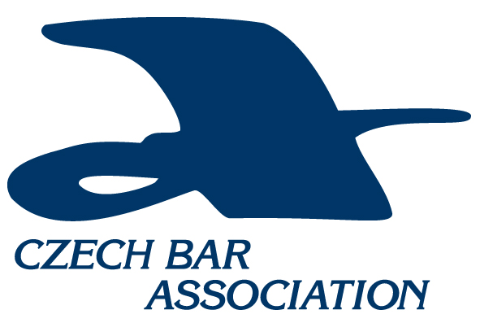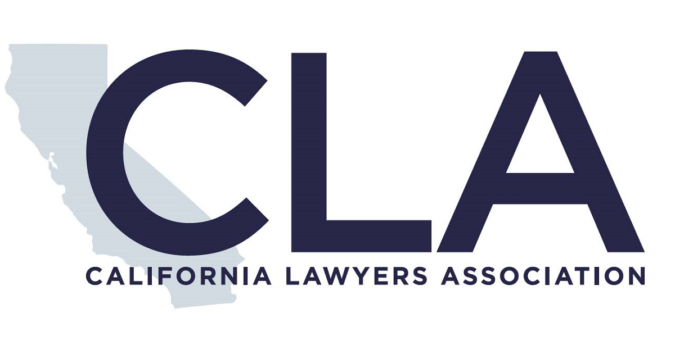  - October 18, 2019  Czech-California Multi-Bar Delegate Law Conference | Prague, Czech Republic  ____  Oct 18, 2019  ____  All in one flat fee includes Conference, meals & tour  Czech Bar ASsociation  Národní 16  110 00 Prague  +420 273 193 140  www.cak.cz

  - ProgramME agenda

The Conference will take place on Friday 18 October 2019 from 09.00 in the premises of the Czech Bar Association, Palác Dunaj, Národní 11, Prague 1, entry from Voršilská street 14.
The conference will be held in English.
The program is subject to change.

9.00 Registration
9.30 Welcome remarks:
- Robert Němec, Vice-President of the Czech Bar Association
- Antonín Mokrý, Chair of International Law Section of the Czech Bar Association
- Josh Surrowitz, Chair of International Law Section of the California Lawyers Association
- Alexandra Darraby, Co-Chair of the International Law Section of the California Lawyers Association

  - - 10.45
Comparative Bar Association Regulation, Rule of Law and Human Rights: What Justice Means in International Law Practices

Leadership will discuss the regulation and functioning of lawyers and implementation of domestic and international laws under the rules and restrictions of their Bar Organizations, specialized courts, and general laws. Legal regulators, Bar leaders and practitioners from California and other International Jurisdictions will analyze the legal and institutional precepts of cross-border Attorney Practice and Licensure Rules and implications of virtual lawyering clients in their own jurisdictions. Comparative evaluation of how different Bar Associations foster Rule of Law, implement Human Rights through education and outreach Advocacy and implementation of client protections in a cross-border environment. The panel will discuss what Public Education resources are available to practitioners, and analyze practical issues related to dealing with attorneys licensed in foreign jurisdictions.
Moderator: Alexandra Darraby
Speakers: James Hill, Eva Indruchová, Antonín Mokrý

  - – 11.00 Break

11.00 – 12.00
Cross-Border Effects of New Privacy Laws in California and the European Union: Compliance, Vigilance and Protection of e-communications with clients, data security, surveillance, and drones

The new EU Data Privacy and California Privacy Law have changed the internet environment for media, commerce and lawyers. Whether you represent companies, attorneys, creators, service industries, work a blog, work as a lawyer or consultant, or do just about anything virtually on the internet, the analysis of this panel applies. Massive breaches of security and privacy data by public entities, governmental agencies, private companies, social media platforms and financial megaliths traded on NASDAQ have all had data breaches where supposedly “secure” data prevention systems have not prevented hacks into user’s personal data.
These new laws purport to regulate both recipient use and recipient disclosure to users and have varying abilities to terminate offending sites and issues fines and penalties for noncompliance.
Learn how to coordinate cross border privacy compliance, the metrics of compliance and how to navigate the intricacies of websites, e-promos, legal services, and e-tail under ever increasing patchwork of e-law, domestic and international.
Coupled with privacy are surveillance issues of locations and activities as drones, devices, artificial intelligence, and your very own cell phones are tracking you. Learn from experts the legal boundaries, who regulates them, and what you can do to protect your own practice and your clients.
Moderator: Steven Richman
Speakers: Holger Bielesz, Alice Frýbová, Susan Brushaber, Pavlina Hlavenková

12.00 – 13.30 Lunch - Café Louvre
13.45 – 14.45
Art, Architecture, Film: Legal Nexus of Real Property, Moral Rights, Digital Rights, Technology and Urban Development

America’s joining the international Berne Convention in late 20th Century required common law adaptation to civil law precepts. The Czech Republic is home to award winning novelists, film makers, and artists. This panel parses how 21st century practice necessitates knowledge of the laws of European Union, United States, national laws and international treaties. Culture and preservation of art and architecture has different historical legacy in Europe and the Czech Republic than in America, and the effect of differing regulation impacts architectural preservation and the urban landscape in which all of us work. Experts will explain realty law and how urban planning regulation impacts architectural treasures in historic gems like Prague, a city rich in legacy of many civilizations, regimes, and democracy.
Moderator: Alexandra Darraby
Speakers: Marsha Brooks, Alexandra Darraby, LeAnn Shelton

14.45 - 15.00 Break

15.00 - 16.00

Remote Communication with Clients, Lawyers’ Use of Online Legal Platforms, Internet and Clouds

This Panel focuses on practical issues in the setting of law practice management and communications challenges dealing with clients in other time zones and cultures. With today’s abundant information and communication technology, it is more possible than ever for attorneys and their clients to work with others across the globe. Attendees will learn about the latest technological applications being used by practitioners and compare what techniques and technology attorneys are more pervasive and available in each jurisdiction.
Moderator: Susan Brushaber
Speakers: Martin Maisner, Josh Surowitz, Jiří Novák

16.00 - 17.00
Professional Rules, Disciplinary Proceedings and Unauthorized Provision of Legal Services

This Panel compares and analyzes the ethical and disciplinary rules in their respective jurisdictions, including how they deal with the unauthorized provision of legal services, and how internet affects rendering services to clients communicating with third parties. Practitioners will learn about infrastructures in place to help protect clients and others in the community from substandard or illegal legal services. The panel will also address professional rules that arise in context of working with attorneys and clients in foreign jurisdictions, including the ethics of sharing legal fees with foreign attorneys.
Moderator: Zbyšek Kordač
Speakers: Kirsten Dodge, Steven Richman, Robert Němec

