European Lawyers in Lesvos - Application form for volunteer lawyers
Basic information:
Surname _________________________ Name _______________________________
Gender _________________________
Address ____________________________________________________________________
Mobile phone number ___________________________________________
Email-address __________________________________________________
Nationality __________________________________________________
Date of birth __________________________

Professional information:

Member of ________________________ Bar since ________________________
CCBE Member bar/law society _______________________________________________________
Experience in Asylum Law practice (in years/number of cases) _________________
Other relevant experience in dealing with migrant affairs ______________________

Language Competences:
Languages | Level
 | Native | Fluent | Intermediate | Beginner
English
Arabic
Greek
Farsi
French
Other
___________

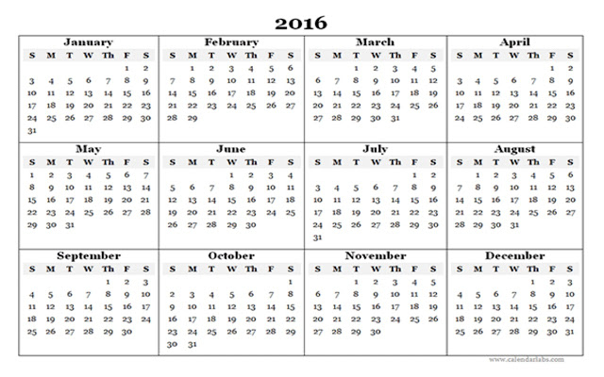
Availability in calendar weeks in 2016 (please circle/highlight):
Preferred period of volunteer activity (min. 2 consecutive weeks) ____________

Please attach the following documents:
- A copy of certificate of admission to/membership of the bar
- Curriculum Vitae
- Please describe in one page why you are suitable for this project (in English)

